A Systematic Literature Review of Retrieval-Augmented Generation (RAG) Models: Architectures, Applications, And Emerging Challenges
Authors:
Dr. Afsheen Khalid and Shahid Azam

Abstract
This systematic literature review aims to examine the existing body of literature on Retrieval-Augmented Generation (RAG) architecture, applications, and emerging challenges in the field, as well as to identify current research trends and future research opportunities. The systematic literature review was conducted following the Preferred Reporting Items for Systematic Reviews and Meta-Analysis (PRISMA) structure and was limited to papers published in English after the year 2020. A total of 30 research papers were extracted from databases such as IEEE Xplore, ACM Digital Library, Springer Link, Science Direct, Scopus, and Google Scholar. The findings of this review are that Retrieval-Augmented Generation improves factual accuracy, reduces hallucinations and improves the generation of reliable text by retrieving information from external sources before text generation. While traditional RAG architecture relies upon the interaction between a retriever, an external knowledge base, and a generator, several advanced architectures have been proposed in recent studies that incorporate various retrieval methods. The healthcare industry is the most extensively investigated field in which Retrieval-Augmented Generation is being applied, followed by education, finance, enterprise knowledge management, legal systems and scientific research. The most commonly cited issues that arise in the use of Retrieval-Augmented Generation include retrieval errors and hallucination, reliability of responses, narrow setting boundaries, computational complexity, lack of standardization of evaluation frameworks, privacy and security concerns. As for future research, improvements to the efficiency of Retrieval-Augmented Generation, multimodal integration, reasoning, privacy-preserving mechanisms, and standard evaluation practices are suggested.
Keywords: Retrieved-Augmented Generation, Systematic Review, RAG Architecture, RAG Applications, Emerging Challenges

INTRODUCTION
The Large Language Models (LLMs) have been exploding with growth—and there is good reason for: They get better at comprehending and writing human-like text by the second! While they are quite impressive in their capabilities, traditional LLMs have several drawbacks, such as hallucination, antiquated knowledge, lack of transparency, and the inability to retrieve external information [2, 3]. That's why researchers have been looking at creating hybrid frameworks that combine the best features of information retrieval systems and generative language models. An interesting application of this is Retrieval-Augmented Generation (RAG), where the language model fetches relevant information from an external knowledge source before generating a response [4]. So regular LLMs can answer questions based on their training, they're pretty good at understanding and generating natural language, but they're constrained by their knowledge, such as what's in their training set [5]. RAG systems, however, can generate answers that are much more factual, informative, and accurate: they are a combination of the features of info retrieval systems and the linguistic features of modern language models [6]. But here's the thing: RAG systems draw information from trusted sources before producing answers, making them much less prone to churning out inaccurate information – particularly vital in fields like healthcare, the law, finance, and scientific research where accuracy is paramount and errors can have significant effects. Traditional LLMs have a limited capacity to integrate new information; they cannot do it magically [7]. RAG can ingest the newest and best from outside sources without needing to update the language model, which allows companies to keep their AI systems current, even as new information emerges constantly [8]. The RAG framework - it's basically made up of two key parts: the retriever and the generator, which work together seamlessly to process user queries and spit out informative responses [8]. Modern RAG systems are generally based on dense retrieval, and they take both the documents and the user's queries and embed them numerically using embedding models [9] - imagine having a giant library where each book is assigned a unique, number-like identifier that can be easily searched. These vectors are then stored in a vector database, and using similarity matching, documents semantically relevant to the query are retrieved – finding the needle in the haystack, you said. Then, the retriever ranks these documents by relevance and extracts the most useful info for further processing [4]. RAG is now being adopted by businesses and organizations as a powerful tool for enterprise knowledge management, as it enables staff to easily retrieve information from internal documents, reports, manuals, and policy repositories, thus accessing organizational knowledge more quickly and easily to make informed decisions [10]. But as generative AI becomes more popular in various industries, RAG's value has also increased - it can solve some major problems of traditional language models, and enhance the accuracy, reliability and trustworthiness of AI systems [11]. There are challenges, such as relying on retrieval quality, having to deal with large amounts of information because of the context limitations of language models, as well as the fact that both retrieval and generation are very heavy on the calculations, thus increasing the costs of operations and system complexity [12]. Overcoming these challenges is essential for enhancing the capabilities of RAG systems in real-world applications, making them more effective, scalable, and trustworthy. Although the research field of RAG is widely used, the literature is dispersed and makes it difficult for researchers to put their finger on the development and current state of the research field. That's where a systematic review comes in – to collate and pull together existing knowledge and experience by identifying key architectural trends, the current application of these, and the ability of each RAG to work effectively. The main goal of this research is to bring together the existing knowledge to pave the way for future innovations and to build more trustworthy, efficient and reliable retrieval-augmented generation systems.

2: RESEARCH METHODOLOGY
The current research used a systematic prose examine analysis design to analyze prevailing intelligence over the RAG model, especially in terms of their architecture, intention and growing resistance. Person investigations typically take precedence over precise aspects of RAG, such as the retrieval mechanism, lingo modeling integration, realm adaptation, or performance appraisal. They often provide a divergent view of the overall study [13] during the above examinations;. For this reason, a systematic assessment is necessary to consolidate the findings of a number of sources and provide an integrated position at the forefront of the development of RAG systems. The present study uses qualitative analysis as the main focus was on interpretation, classification, and synthesizing the wisdom gained from the previous print analysis.
In order to obtain a thorough survey of questions, various scholastic databases were used as primary sources of literature which can be both fictional and non-fictional using databases i.e. Google Scholar, IEEE Xplore, Springer Link, Science Advisor, and Scopus. These sources were selected so they are widely recognized as the repository of the premium exploration publication [ 14 ]. The investigation followed the standard of involvement and rejection in the selection of documents. An analysis focusing on the RAG model, including its architecture, functions, performance appraisal, execution method, and evolving obstacles as full-text, peer-reviewed diary article published later 2020. The analysis was not directly related to RAG, extra publication, non-English article, peer-reviewed beginning, and that print publication prior to 2020 were excluded from the final synthesis.
After the establishment of the article was identified using the screening and selection method, relevant information was collected and categorized according to the objectives of the assessment. Publication details, analysis objectives, RAG architecture, retrieval methods, practice area, performance implications, and identified obstacles. Thematic review was used to carry out the review, wherein the principles, form, and results were recognized within the limits of the selected text. Following thematic classification, conclusions from different studies were compared and synthesized to identify common patterns, useful improvements, and research gaps. To provide a comprehensive briefing on the current RAG investigation, correlations and differences were analyzed within the intended approach. The synthesized findings were summarized systematically, focusing on key findings, feasible outcomes, and analysis opportunities for the future.

3: DATA ANALYSIS AND FINDINGS

4.1: Paper Synthesis
A total of 250 studies were initially identified from several academic databases, using the Preferred Reporting Items for Systematic Reviews and Meta-Analysis (PRISMA) framework. 40 duplicate records were eliminated and 210 studies were subsequently screened by title and abstract. In screening 120 studies were excluded due to not meeting the scope of the review and 90 studies were included for full text review. After the process of eligibility review, those studies which were not relevant or lacked adequate information were excluded: 60 studies. Finally, 30 studies were included in the systematic literature review.

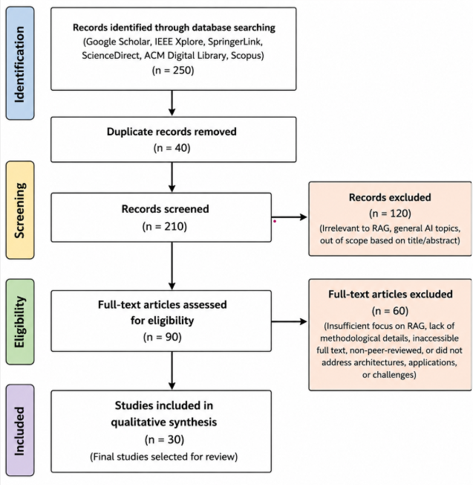
Figure 3.1: PRISMA Framework
These selected studies were evaluated for quality, credibility and methodological rigour by using the Critical Appraisal Skills Program (CASP) framework. The results indicated that the majority of the studies included clearly stated research purposes, suitable research methods, and clear data collection and analysis. The overall quality of the research in most studies was good enough to provide adequate evidence for RAG architectures, applications, and their performance evaluation. Few studies, however, reported limitations in their methods or descriptions, in their discussion of possible biases, and in their reporting of evaluation procedures. Selected studies were judged to be acceptable for the systematic review and this was supported by the CAPS assessment which indicated that they were satisfactory in quality and appropriate for the review. . . .
The reviewed papers were published during 2023-2026 with publications 2023 (2), 2024 (9), 2025 (16), and 2026 (3) papers. The papers reviewed were published in highly reputable journals and conference proceedings and the Applied Sciences journal published the most papers, followed by the Journal of Medical Internet Research, the ACM Computing Surveys, the Journal of Biomedical Informatics, the Business & Information Systems Engineering and the Information and Libraries journal. The distribution of the number of academic papers published by year and by Journal clearly illustrates the increased academic interest in RAG over the last few years, spanning the areas of artificial intelligence, healthcare and information systems.

4.2: Key Features
All of the reviewed studies show RAG as an important advancement in LLM research. Instead of using pre-trained model parameters alone, RAG augments the response generation process with retrieval from external knowledge bases prior to the generation of the response [13, 14, 15, 16]. RAG architecture generally integrates three key components, i.e., a retriever, an external knowledge base, and a generator, allowing language models to access dynamic and domain-specific information during interference [17], [18], [19], [20], [21]. Recent architectural developments, including hybrid retrieval methods, chain-of-retrieval mechanisms, and structured retrieval frameworks, have significantly enhanced retrieval efficiency and response quality while enabling more complex reasoning capabilities[11], [22]. Generative AI systems combine the strengths of information retrieval with advanced language generation [23], [24], [25]
In healthcare, researchers demonstrated that RAG improves clinical decision support, medical question answering, electronic health record summarization, COVID-19 fact-checking, and medical fitness assessment by generating responses grounded in verified medical evidence [22], [26], [27], [28], [29], [30]Similarly, enterprises and industrial applications showed that RAG enhances organizational knowledge management, document automation, intelligent search, and decision support by retrieving relevant organizational knowledge before response generation [31], [32], [33]Other studies reported successful applications in academic libraries, financial analysis, document question answering, open-domain question answering, and educational chatbots, demonstrating the flexibility of RAG across knowledge-intensive tasks [34], [35], [36], [37], [38].
Despite these advances, studies consistently identified challenges related to retrieval accuracy, computational costs, scalability, privacy protection, context management, and standardized evaluation metrics [13], [14], [15], [17], [24]

4.3: Architecture of RAG
The reviewed questions show that the architecture of the RAG model is designed to improve the real accuracy and contextual relevance of LLMs by integrating intelligence retrieval with text coevals. Most studies describe the RAG architecture as consisting of three basic components, i.e. , retriever, awareness core, and generator. Retrievers retrieve important data from external knowledge bases, information base shop structure, or unstructured document, and a generator creates a response by combining the information retrieved with the second question of the user [13], [15], [19]
Conventional architecture was proposed to overcome the restriction of standalone LLMs by allowing access to external, continuously modified wisdom rather than trusting only the model parameters [13], [17], [19]The conventional RAG skeleton significantly improves the accuracy of the response, reduces the illusion of a falsehood, and improves the intelligence base, which makes it acceptable for the task of performing knowledge-intensive tasks such as question answering, paper summaries, and information retrieval [15]. To overcome the limitations of the traditional retrieval generation paradigm, a few of the analyses propose advanced and hybrid RAG architecture. The above architecture integrates dense retrieval, sparse retrieval, hybrid retrieval, graph-based retrieval, iterative retrieval, and a chain-retrieval mechanism to improve record relevance and deduction skills [7] Hybrid architectures effectively combine the strengths of different retrieval methods, enabling more complete wisdom retrieval and improving the quality of the generated response. High-tech frameworks facilitating multi-step deduction, active retrieval, and adaptive understanding integration lead to higher precision and robustness across the undertakings and domain-specific functions [23], [24], [25]
The main functional components of the RAG system are considered to be the retriever and the generator. , alongside their performance directly influences the quality of the generated end product, retrievers must be capable of separating the primarily important data from the external wisdom depository using methods such as dense vector retrieval, spare retrieval, and embedding-based semantic search, while the generator uses retrieval of information to produce coherent and contextually appropriate responses [13]. The improved retrieval procedures, the implanted model, and the transformer-based generator have improved the efficiency, real consistency, and contextual relevance of the RAG arrangements, thus reducing the hallucination and improving the responsiveness of the RAGs.
Comparative analysis of reviewed analysis shows that current RAG architectures, which integrate external information retrieval prior response coevals, systematically outperform conventional LLMs. While traditional RAG architectures provide meaningful improvements in actual accuracy and insight, high-tech and hybrid architectures provide superior retrieval precision, scalability, logic skills, and versatility in multidisciplinary training domains [14], [23], [24] Scholars also noticed that architectures using hybrid retrieval schemes, structure information integration, and iterative retrieval achieve higher performance than conventional retrieval strategies, particularly in complex reasoning and domain-specific purposes such as healthcare, financing, and enterprise intelligence [22], [27], [33]
The summary of the RAG architecture is presented in the figure;
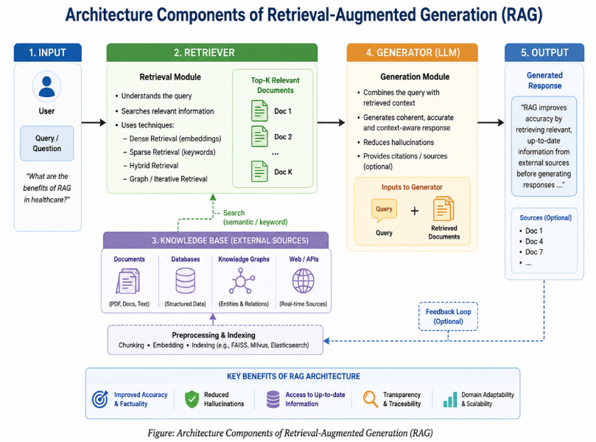

4.4: Applications of RAG Models
Healthcare represents the most extensively studied application domain of RAG models [7], [26]. This is because RAG can enhance factual accuracy, reduce hallucinations, and aid in evidence-based clinical decision-making. The capabilities of RAG are valuable in the healthcare domain, where they can contribute to the improvement of healthcare services and support medical professionals in knowledge-intensive tasks [27], [28], [29], [30], [39]. The researchers found that RAG-powered educational chatbots, intelligent tutoring systems, and academic library search platforms can offer students and educators accurate, context-aware, and up-to-date information, by first fetching relevant educational resources and then generating the content [34], [38]. The benefits of RAG systems in personalized learning, improving access to academic knowledge, and enabling research are increasingly apparent as they help to reduce misinformation and make generated content more relevant [13], [40]. Likewise, financial and Banking can be analyzed more accurately with RAG models, minimizing information distortion, and delivering more accurate financial information, which aids in better investment analysis, risk assessment, and organization decision-making [32], [35], [36]. Moreover, RAG legal systems enhance legal research efficiency and aid legal practitioners in managing extensive complex legal documents [13, 14, 24].
By enabling employees to retrieve relevant organizational knowledge from internal repositories before generating responses, RAG improves operational efficiency, knowledge sharing, productivity, and decision-making across the enterprise environment [20], [31], [32], [33]. Researchers applied RAG to automated literature retrieval, evidence synthesis, document question answering, open-domain question answering, industrial research, and knowledge discovery by integrating external scholarly databases with large language models. The findings revealed that continued advancements in retrieval mechanisms and language models further expand the adoption of RAG across emerging application areas [16], [23], [25], [31], [37].
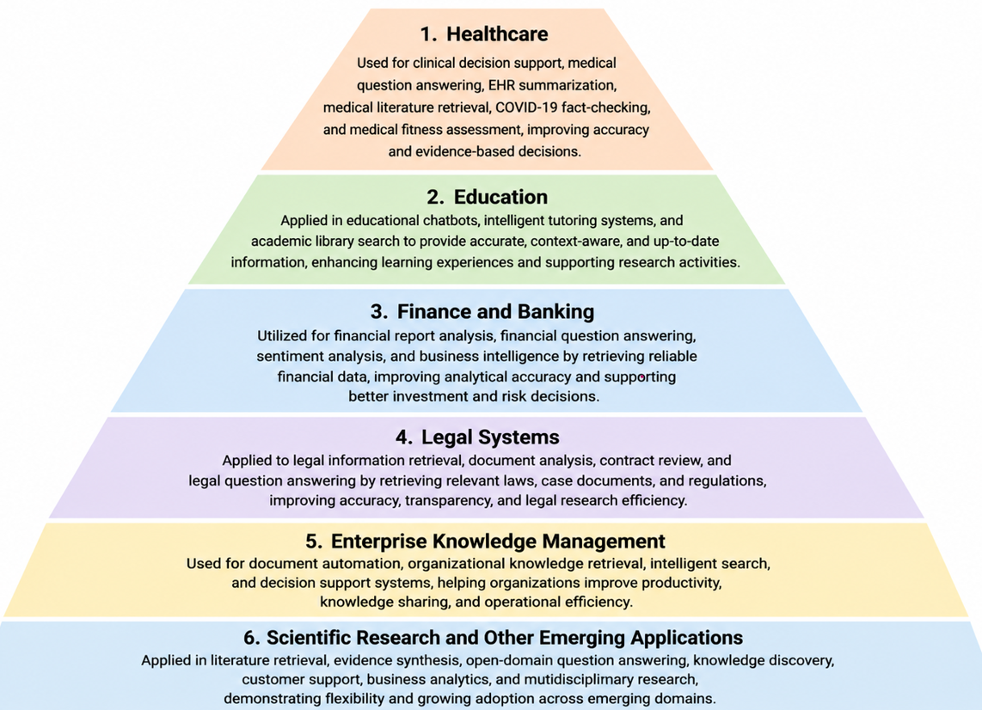
Figure 2: Applications of RAG Models

4.5: Emerging Challenges of RAG Models
The reviewed studies showed that, despite the significant progress made by the RAG Model in improving the performance, relevance, and reliability of LLMs, several obstacles are still preventing their widespread adoption and realistic implementation. Retrieval accuracy is one of the most important obstacles affecting the performance of the RAG model. The productivity of file selection is frequently reduced by semantic ambiguity, inefficient indexing, and restriction of retrieval algorithms, especially when the task involves other domain-specific questions [13]. Therefore, the main research focus is on improving retrieval accuracy using high-tech retrieval approaches and improved implant models. [14], [15]The reviewed examinations show that even in the absence of an error, partial or otherwise conflicting recovery details may still lead to an inaccurate or otherwise inaccurate production [17]. Furthermore, the lack of consistency between the recovery document and the internal intelligence of the dialect model has a negative impact on the reliability of the response [23]. To guarantee a reliable and factually constant final product, Sharma and Bhattarai (2026 ) pointed out the importance of improving retrieval capability, indication confirmation, and response validation [24]
When different documents are recovered, only a portion may be integrated into the coevals procedure, likely to be supreme in order to avoid the lack of essential information which is particularly important for purposes including the extracted document, scientific literature, valid information, and the enterprise awareness repository [21]. Wang et al. ( 2026 ) proposes that in order to improve awareness use, additional effective circumstances management and file prioritization approaches are needed [13]. On the other hand, Oche et al. ( 2025 ) argue that RAG frameworks require large computational resources if they combine file retrieval, implant coevals, indexing, and dialect model inference within a single framework [25]. As more intelligence foundations are added, retrieval rotational latency and system costs increase, making large-scale usage exceedingly difficult[13]. The reviewed research notes that retrieving facts from external databases expose confidential or proprietary information unless appropriate entry control and protection mechanisms are not implemented [32] . Neha et al. In 2025, the need to provide defensed retrieval systems, statistics encoding, direct entry rules, and self-learn approaches to safeguard administrative obedience and defend delicate information was highlighted [30].
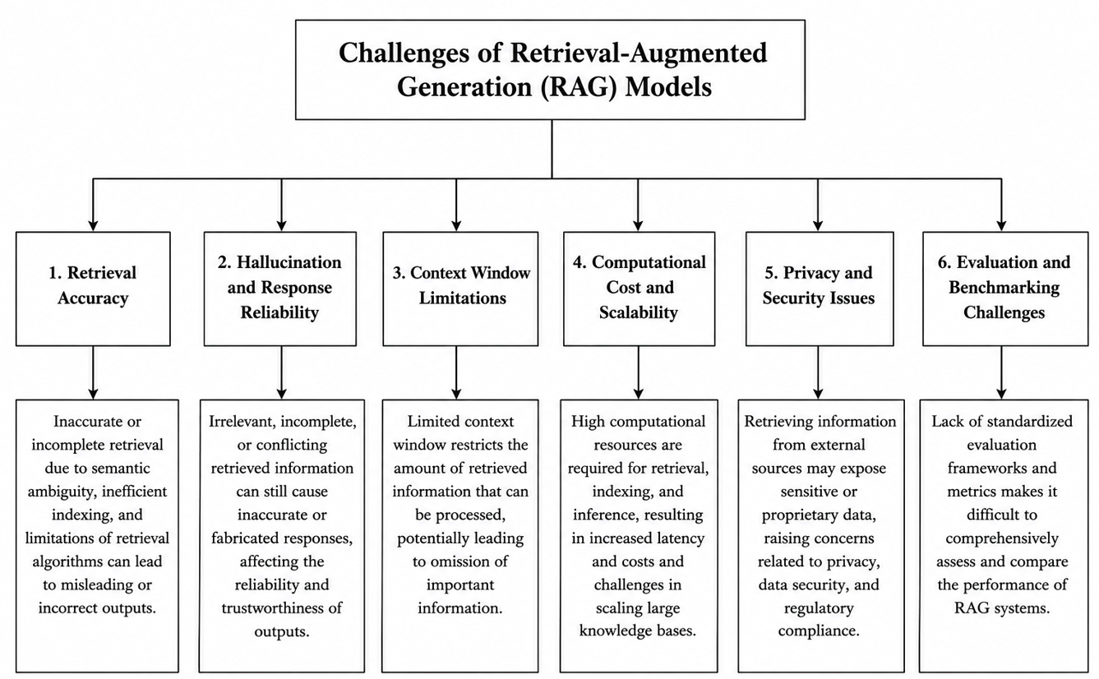

5: Conclusion and Future Research
Retrieval-Augmented Generation (RAG), unlike conventional language models relying solely on pre-trained parameters, enables access to active and domain-specific insights, thus accelerating real accuracy, contextual relevance, and response dependability [3], [10]. The current systematic critique aims at critically reviewing the existing expertise on top of the RAG architecture, objectives, and emerging difficulties in determining new investigative patterns and future study opportunities. The investigative body adopted a systematic prose critique method based on the PRISMA guidelines to ensure transparency and structure of the investigative choice procedure. After using the involvement and expulsion standards and measuring methodological quality using the CASP, a final sample of 30 peer-reviewed studies was selected for the thematic synthesis and qualitative study.
The results show that research on RAG has been rapidly expanding in recent years, particularly following the widespread acceptance of a large mother tongue model. The reviewed investigations systematically show that RAG improves the accuracy of the analysis, reduces the hallucinations, enhances the intelligence base, and generates a more reliable response by retrieving important details from external sources, even before the text coevals. While the conventional RAG architecture is grounded in the interaction between retrievers, an external intelligence base, and a generator, recent research presented high-tech and hybrid architecture integrate dense retrieval, sparse retrieval, graph-based retrieval, iterative retrieval, and a chain-of-retrieval mechanism [19] The current literature shows that the RAG model has been successfully applied in a wide range of applications, i.e. Medical aid is the most comprehensively examined area, followed by study, banking, enterprise intelligence, and scientific [10], [26]and scientific [34].
Despite these developments, the research found a number of significant obstacles which continued to affect the performance and pragmatic implementation of the RAG arrangements. The most frequently reported problems include retrieval accuracy, hallucination, and response dependability, narrow background windows, computational complexity, scalability, autonomy, and safety issues, and the absence of standard valuation frameworks [13], [25]. The results above indicate that RAG represents a revolutionary method for advancing precise, understandable, and knowledge-based intelligent automation frameworks, which also includes a number of areas that require further investigation. It is recommended for approaching investigations in order to focus on advancing further streamlined and correct retrieval mechanisms to improve the general performance of the RAG model during minimization of hallucinations and advancing actual consistency [41]. There is a need to develop a standard assessment paradigm and benchmark data that provide fair comparisons between the unique RAG architecture and the applications.

References
[1] V. Zolfaghari, N. Petrovic, F. Pan, K. Lebioda, and A. Knoll, “Adopting RAG for LLM-Aided Future Vehicle Design,” Nov. 2024.
[2] J. Devlin, M. W. Chang, K. Lee, and K. Toutanova, “BERT: Pre-training of deep bidirectional transformers for language understanding,” in NAACL HLT 2019 - 2019 Conference of the North American Chapter of the Association for Computational Linguistics: Human Language Technologies - Proceedings of the Conference, Association for Computational Linguistics (ACL), 2019, pp. 4171–4186.
[3] B. Tural, Z. Örpek, and Z. Destan, “Retrieval-Augmented Generation (RAG) and LLM Integration,” in 8th International Symposium on Innovative Approaches in Smart Technologies, ISAS 2024 - Proceedings, Institute of Electrical and Electronics Engineers Inc., 2024. doi: 10.1109/ISAS64331.2024.10845308.
[4] Y. Feng et al., “Hyper-RAG: combating LLM hallucinations using hypergraph-driven retrieval-augmented generation,” Nat. Commun., Apr. 2026, doi: 10.1038/s41467-026-71411-1.
[5] S. Vakayil, D. Sujitha Juliet, J. Anitha, and S. Vakayil, “RAG-Based LLM Chatbot Using Llama-2,” in ICDCS 2024 - 2024 7th International Conference on Devices, Circuits and Systems, Institute of Electrical and Electronics Engineers Inc., 2024, pp. 195–199. doi: 10.1109/ICDCS59278.2024.10561020.
[6] R. Schwartz, J. Dodge, N. A. Smith, and O. Etzioni, “Green AI,” Commun. ACM, vol. 63, pp. 54–63, Nov. 2020, doi: 10.1145/3381831.
[7] X. Du et al., “Vul-RAG: Enhancing LLM-based Vulnerability Detection via Knowledge-level RAG,” ACM Transactions on Software Engineering and Methodology, Feb. 2026, doi: 10.1145/3797277.
[8] D. Araci, “FinBERT: Financial Sentiment Analysis with Pre-trained Language Models,” Aug. 2019.
[9] N. Karanikolas, E. Manga, N. Samaridi, E. Tousidou, and M. Vassilakopoulos, “Large Language Models versus Natural Language Understanding and Generation,” in ACM International Conference Proceeding Series, Association for Computing Machinery, Nov. 2023, pp. 278–290. doi: 10.1145/3635059.3635104.
[10] K. K. Y. Ng, I. Matsuba, and P. C. Zhang, “RAG in Health Care: A Novel Framework for Improving Communication and Decision-Making by Addressing LLM Limitations,” NEJM AI, vol. 2, Jan. 2025, doi: 10.1056/aira2400380.
[11] Y. Hou and R. Zhang, “Enhancing Dietary Supplement Question Answer via Retrieval-Augmented Generation (RAG) with LLM,” Sep. 2024. doi: 10.1101/2024.09.11.24313513.
[12] K. Sundar, E. Manohar, K. Vijay, and S. Prakash, “Revolutionizing Assessment: AI-Powered Evaluation with RAG and LLM Technologies,” in 2nd International Conference on Self Sustainable Artificial Intelligence Systems, ICSSAS 2024 - Proceedings, Institute of Electrical and Electronics Engineers Inc., 2024, pp. 43–48. doi: 10.1109/ICSSAS64001.2024.10760285.
[13] Y. Gao, Y. Xiong, Y. Zhong, Y. Bi, M. Xue, and H. Wang, “Synergizing RAG and Reasoning: A Systematic Review,” Apr. 2025.
[14] S. Gupta, R. Ranjan, and S. N. Singh, “A Comprehensive Survey of Retrieval-Augmented Generation (RAG): Evolution, Current Landscape and Future Directions,” Oct. 2024.
[15] M. Dimitrova, “Retrieval-Augmented Generation (RAG): Advances and Challenges,” Problems of Engineering Cybernetics and Robotics, vol. 83, Jul. 2025, doi: 10.7546/pecr.83.25.03.
[16] F. Huang, D. Mei, C. Yang, C. Su, and R. Ma, “Knowledge-driven automated prefabricated bridge modeling from natural language using LLM and RAG,” Sci. Rep., May 2026, doi: 10.1038/s41598-026-53765-0.
[17] A. K. Shahade and P. V. Deshmukh, “Enhancing Natural Language Processing: A Comprehensive Review of Retrieval Augmented Generation,” in 4th International Conference on Sustainable Expert Systems, ICSES 2024 - Proceedings, Institute of Electrical and Electronics Engineers Inc., 2024, pp. 609–611. doi: 10.1109/ICSES63445.2024.10763224.
[18] A. V. Shah, S. Menghani, S. Yu, and P. Jordan, “Bespoke Ad Targeting via LLM-Generated User Profiles and RAG-Based Recommendations,” in IEEE International Conference on Artificial Intelligence and Knowledge Engineering, AIKE, Institute of Electrical and Electronics Engineers Inc., 2026, pp. 131–134. doi: 10.1109/AIxDKE67294.2026.00030.
[19] R. Shan and T. Shan, “Retrieval-Augmented Generation Architecture Framework: Harnessing the Power of RAG,” in International Conference on Cognitive Computing , 2024.
[20] M. Klesel and H. F. Wittmann, “Retrieval-Augmented Generation (RAG),” Business and Information Systems Engineering, vol. 67, pp. 551–561, Aug. 2025, doi: 10.1007/s12599-025-00945-3.
[21] P. Jiang, S. Ouyang, Y. Jiao, M. zhong, R. Tian, and J. Han, “Retrieval And Structuring Augmented Generation with Large Language Models,” ACM Digital Library, vol. 2, Mar. 2025, doi: https://doi.org/10.1145/3711896.373655.
[22] L. Wang, H. Chen, N. Yang, X. Huang, Z. Dou, and F. Wei, “Chain-of-Retrieval Augmented Generation,” https://proceedings.neurips.cc/paper_files/paper/2025/hash/566aad4fac1acf17fd1ae8c3aef75326-Abstract-Conference.html.
[23] S. Mohammed, P. H. Bhasha, O. Gervasi, and R. Bose, “A Survey on Retrieval-Augmented Generation (RAG) and Hybrid Information Retrieval for Large Language Models,” Synthesis: A Multi-Disciplinary Journal .
[24] P. Sharma and S. Bhattarai, “A Review on Retrieval-Augmented Generation: Architectures, Research Challenges, and Emerging Frontiers,” Journal of Future Artificial Intelligence and Technologies, vol. 2, pp. 616–628, Jan. 2026, doi: 10.62411/faith.3048-3719-297.
[25] A. J. Oche, A. G. Folashade, T. Ghosal, and A. Biswas, “A Systematic Review of Key Retrieval-Augmented Generation (RAG) Systems: Progress, Gaps, and Future Directions,” Jul. 2025.
[26] M. Alkhalaf, P. Yu, M. Yin, and C. Deng, “Applying Generative AI with Retrieval Augmented Generation to Summarize and Extract Key Clinical Information from Electronic Health Record,” J. Biomed. Inform., 2024, doi: 10.1016/j.jbi.2024.104662.
[27] Y. H. Ke et al., “Retrieval augmented generation for 10 large language models and its generalizability in assessing medical fitness,” NPJ Digit. Med., vol. 8, Dec. 2025, doi: 10.1038/s41746-025-01519-z.
[28] H. Li, J. Huang, M. Ji, Y. Yang, and R. An, “Use of Retrieval-Augmented Large Language Model for COVID-19 Fact-Checking: Development and Usability Study,” J. Med. Internet Res., vol. 27, 2025, doi: 10.2196/66098.
[29] Y. Miao, Y. Zhao, Y. Luo, H. Wang, and Y. Wu, “Improving Large Language Model Applications in the Medical and Nursing Domains With Retrieval-Augmented Generation: Scoping Review,” 2025, JMIR Publications Inc. doi: 10.2196/80557.
[30] F. Neha, D. Bhati, and D. K. Shukla, “Retrieval Augmented Generation (RAG) in Healthcare: A Comprehensive Review,” MDPI, 2025, doi: https://doi.org/10.3390/ai6090226.
[31] L.-C. Chen, M. S. Pareshi, Y.-X. Liao, and K.-C. Pai, “Application of Retrieval-Augmented Generation for Interactive Industrial Knowledge Management via a Large Language Model,” in Proceedings - 2024 Conference on AI, Science, Engineering, and Technology, AIxSET 2024, Institute of Electrical and Electronics Engineers Inc., 2024, pp. 166–169.
[32] A. James, M. Trovati, and S. Boltona, “Retrieval-Augmented Generation to Generate Knowledge Assets and Creation of Action Drivers,” in Applied Sciences, Institute of Electrical and Electronics Engineers Inc., 2025, pp. 48–55. doi: https://doi.org/10.3390/app15116247.
[33] E. Karakurt and A. Akbulut, “Retrieval-Augmented Generation (RAG) and Large Language Models (LLMs) for Enterprise Knowledge Management and Document Automation: A Systematic Literature Review,” Applied Sciences, vol. 16(1), 2026, doi: https://doi.org/10.3390/app16010368.
[34] R. V. K. Bevara et al., “ Prospects of Retrieval Augmented Generation (RAG) for Academic Library Search and Retrieval,” Information Technology and Libraries .
[35] I. Iaroshev, Ra. Pillai, L. Vaglietti, and T. Hanne, “Evaluating Retrieval-Augmented Generation Models for Financial Report Question and Answering,” Applied Sciences MDPI, vol. 14(20), 2024, doi: https://doi.org/10.3390/app14209318.
[36] M. Mathebula, A. Modupe, and V. Marivate, “Fine-Tuning Retrieval-Augmented Generation with an Auto-Regressive Language Model for Sentiment Analysis in Financial Reviews,” Applied Sciences: MDPI, vol. 14(23), Jun. 2024, doi: https://doi.org/10.3390/app142310782.
[37] S. Siriwardhana, R. Weerasekera, E. Wen, T. Kaluarachchi, R. Rana, and S. Nanayakkara, “Improving the Domain Adaptation of Retrieval Augmented Generation (RAG) Models for Open Domain Question Answering Open Access,” in Transactions of the Association for Computational Linguistics, Association for Computational Linguistics (ACL), 2023, pp. 6168–6173. doi: https://doi.org/10.1162/tacl_a_00530.
[38] J. Swacha and M. Gracel, “Retrieval-Augmented Generation (RAG) Chatbots for Education: A Survey of Applications,” Applied Sciences, vol. 15(8), 2025, doi: https://doi.org/10.3390/app15084234.
[39] S. Liu, A. B. McCoy, and A. Wright, “Improving large language model applications in biomedicine with retrieval-augmented generation: a systematic review, meta-analysis, and clinical development guidelines,” Journal of the American Medical Informatics Association, vol. 32, pp. 605–615, Apr. 2025, doi: 10.1093/jamia/ocaf008.
[40] K. Muludi, K. M. Fitria, J. Triloka, and Sutedi, “Retrieval-Augmented Generation Approach: Document Question Answering using Large Language Model,” International Journal of Advanced Computer Science and Applications, vol. 15, pp. 776–785, 2024, doi: 10.14569/IJACSA.2024.0150379.
[41] I. O. William and M. Alamimi, “(PDF) Text Embedding Implementation Using Retrieval Augmented Generation (RAG) Model Combined With Large Language Model,” https://www.researchgate.net/publication/381105654_Text_Embedding_Implementation_Using_Retrieval_Augmented_Generation_RAG_Model_Combined_With_Large_Language_Model.

